Emmanuel Ikogho Okeoghene [emmanuel.ikogho@azubiafrica.org](mailto:emmanuel.ikogho@azubiafrica.org) [oke.kogo@gmail.com](mailto:oke.kogo@gmail.com)

1. What are the total sums of freights of ship cities that have orders from 2 or more customers?

ANS:

SELECT ShipCity,

SUM(Freight) AS TotalFreight

FROM 'Order'

GROUP BY ShipCity

HAVING COUNT(DISTINCT CustomerId)>=2

ORDER BY TotalFreight DESC;

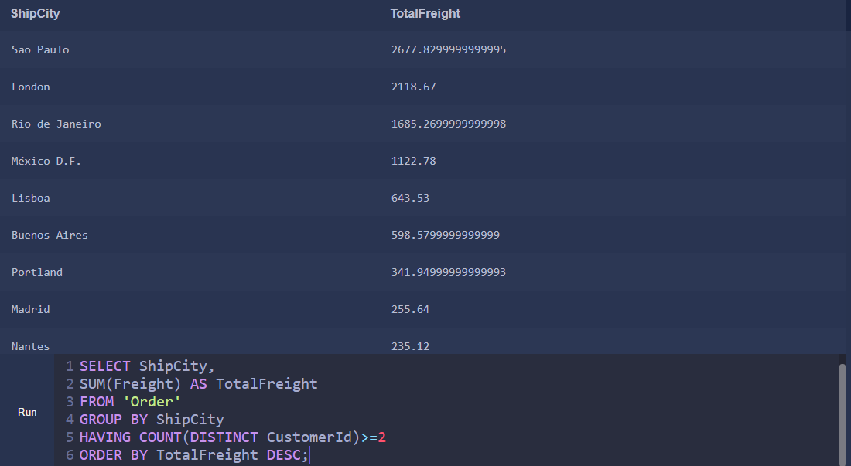

1. Generate a table of employees and the number of customers they handle.

ANS:

SELECT EmployeeId,

COUNT(DISTINCT CustomerId) AS TotalCustomersHandled

FROM 'Order'

GROUP BY EmployeeId;

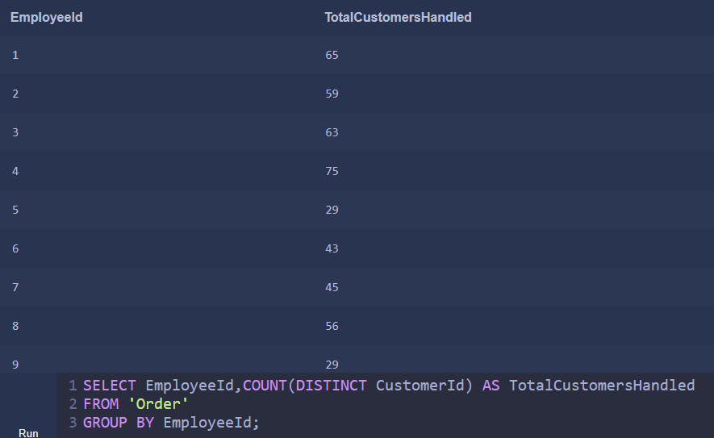

1. How many orders were made each year?

ANS:

SELECT STRFTIME('%Y',OrderDate) AS OrderYear,

COUNT(Id) AS TotalOrders

FROM 'Order'

GROUP BY STRFTIME('%Y',OrderDate);

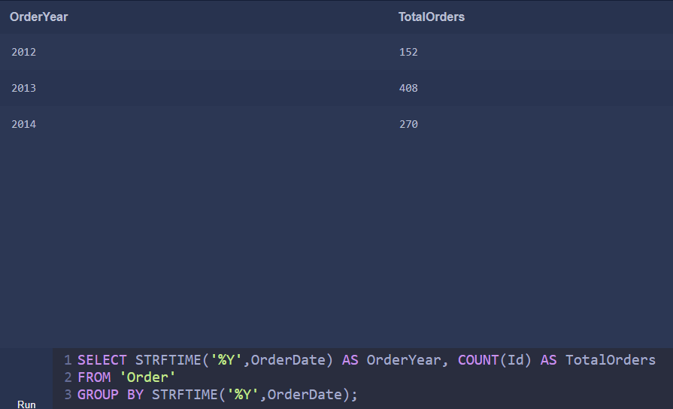

1. What quantity of the product ‘Chang’ was shipped in 2014?

ANS:

SELECT ProductId,

SUM(Quantity) AS TotalQuantity

FROM OrderDetail

JOIN 'Order'

ON OrderDetail.OrderId='Order'.Id

WHERE OrderDate LIKE '2014%' AND ProductId=2;

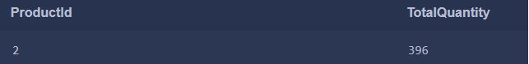

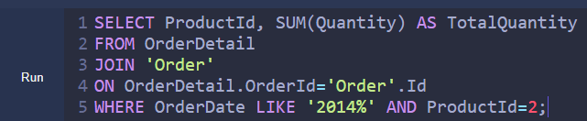

1. What are the revenues per supplier in 2013 before and after discount applied? Show both values in a single table.

ANS:

SELECT Product.SupplierId,

OrderDetail.UnitPrice*Quantity AS RevenueBeforeDiscount,

(OrderDetail.UnitPrice-OrderDetail.UnitPrice*Discount)*Quantity AS RevenueAfterDiscount

FROM 'OrderDetail'

JOIN Product

ON Product.Id='OrderDetail'.ProductId

JOIN 'Order'

ON 'Order'.Id='OrderDetail'.OrderId

WHERE OrderDate LIKE '2013%'

GROUP BY Product.SupplierId;

